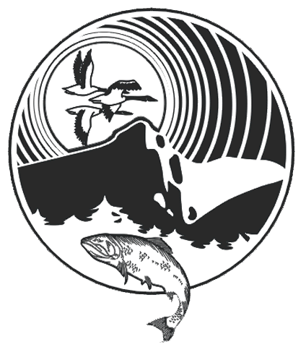

REGIONAL DISTRICT OF BULKLEY-NECHAKO
37 3RD AVENUE – PO BOX 820, BURNS LAKE, BC V0J 1E0
PHONE: (250) 692-3195 – TOLL FREE: (800) 320-3339 – FAX: (250) 692-3305
E-MAIL: HR@rdbn.bc.ca

PLANNER

The Regional District of Bulkley-Nechako is looking for a Planner to play a key role in the Planning Department in a team-oriented work environment. Reporting to the Director of Planning, and under the day-to-day supervision of the Planning and Parks Coordinator the successful candidate will be responsible for processing and evaluating development applications and land use referrals, consulting with professionals and the general public, providing information and assistance to the public on planning issues, preparing plans and reports, and working on parks and trails planning and operations. The work is the first level of professional planning and involves opportunities for independent judgment where the tasks assigned are of a routine nature well defined by precedent.

The preferred candidate will possess a degree from a CIP accredited planning program, with experience working in a local government environment. The candidate should have a basic understanding of the legislation relating to land use planning in BC. The position requires strong written and verbal communication skills, and the ability to work collaboratively with staff, local government politicians, and the public. For a complete job description, please visit www.rdbn.bc.ca.

The Regional District of Bulkley-Nechako provides local government services to an area of more than 77,000 square kilometers of scenic mountains, rolling hills, lakes, and rivers. The office is located in Burns Lake, a dynamic community that is known for its hospitality and as the Gateway to Tweedsmuir Provincial Park. The region offers affordable housing, stunning scenery, world class fishing, and incomparable recreation opportunities.

Applications should be addressed to Jason Llewellyn, Director of Planning at the above address, and will be accepted until 4 pm, Friday, May 7, 2021.

